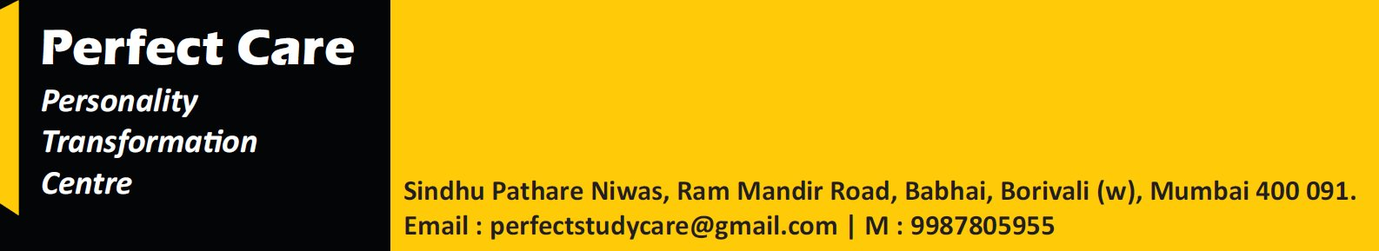

Date : 30/09/2019

To,

Iant Computer Training Institute,

Panjim.

We at perfect care we train students to move a step ahead and stand different from the crowd in their career providing them the updated technology changes. We guide students for website and mobile development. We also conduct short term workshops to make students understand the trending careers. We would like to introduce to you our latest on going workshop ‘MAD with ANDROID’.

**Workshops Modules:**

1. Introduction to mobile app Development.
2. Building user interface with rich controls.
3. Handling data.
4. Communication And Multimedia.
5. Google Play and Publishing.

We have already started this workshop in Colleges in Sawantwadi - Oras in Sindhudurg Dist.

We would request you to allow us to arrange such Android App Development Workshops in your esteemed institution.

Awaiting a positive reply.

Yours Sincerely

Shakira Rajguru

M : 9028582714

**Encl :**

1. **Course Details**

